2001 Panorama Drive
Port Moody, B.C., V3H 5G8
Telephone: 604-461-7680

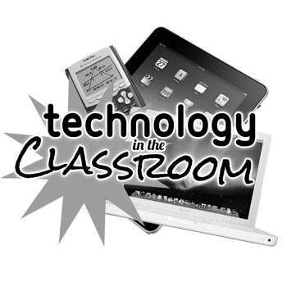

June 2, 2016

Dear Parents and Guardians,

For the past 3 years our grade 4/5 classes have worked with the district in incorporating privately owned devices in the classroom. Students bring their own electronic device (tablets, ipads, surfaces, laptops etc.) to school to enhance their learning. They are used for inquiry based learning, writing, reading, math and many other subject areas. The devices are used at school as a tool to assist with learning.

We are very excited to continue this opportunity for the grade 4/5 classes next year. We will be holding a parent meeting to give you more information about things like storage of the devices, when the students will be using them, how they will be using them and the benefits of this program. Stephen Whiffen, Associate Director of Instruction of Learning and Information Technologies with SD 43, will be attending to talk to this subject.

This meeting will take place on Tuesday, June 21st at 6 pm in the school gym. Some students will be available at the start to share with you some of the ways they have been using their devices. It is our hope that we will be able to answer most of your questions at this meeting. We look forward to meeting you.

Thank you for your time.

Leanne Kemp
Monika Coutts
Ann Kirkhope
Mo Bird
Gary Hernandez
Lindsay Hill
Kelly Cox
Sean Della Vedova
Jason Giles

